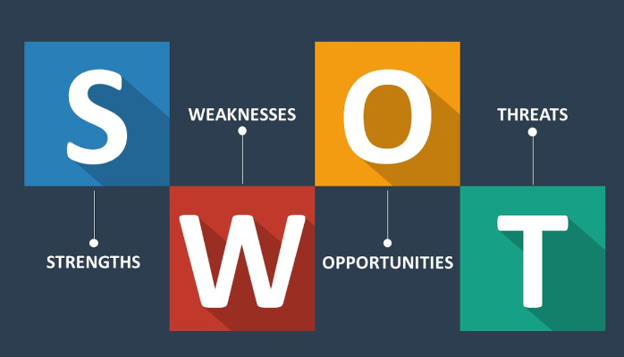

Use the following questions to support you in conducting a self SWOT analysis:

**Strengths (don’t be modest):**

* How do your education, skills, talents, certifications, and connections / networks set you apart from your peers?
* What would your boss or coworkers say are your strengths?
* What resources do you have at your disposal?
* What contributed the most to your past victories?
* What values or ethics do you have that your peers often lack?
* What achievements are you most proud of?

**Weaknesses (be honest):**

* Where are your education, training, or skills lacking? What’s missing and needs improvement?
* What would your boss or coworkers say are your weaknesses or areas of improvement?
* What are your negative work habits and personality traits?  
   What do you avoid because you lack confidence?

**Opportunities:**

* Which opportunities are you not exploiting at the moment?
* What trends are affecting your industry – the industry you belong to or wish to be in?
* In what areas is your industry growing?
* How could new technology help you advance?
* How could your connections and networks help you?

**Threats:**

* What obstacles do you currently face in your career and life?
* Who is your competition?
* Will new technology or certifications demands slow your progress in achieving your goals?
* How is your job or industry changing in ways that could affect your advancement?

S.W.O.T

|  |  |
| --- | --- |
| **Strengths**  I was in stem and technovation challenge of which most of my peers where not.  My peers say that am courageous.  Teamwork, friends and family contributed to my past success.  I am compassionate towards everyone especially the poor.  Am proud of creating an app called INFOTIBA during the technovation challenge. | **Weaknesses**  I am lazy in terms of being punctual (I procrastinate a lot).  I don’t like to be corrected publicly or harshly.  I love sleeping a lot.  I avoid talking to people who are not my peers. |
| **Opportunities**  I lack social networking with my friends back home and family.  Technology has reduced social skills e.g people don’t need to meet so as to talk, they can just sms each other.  The tech Industry is growing In terms of inventions, Innovations and the number of women in tech increases.  My connections will help me get the platform to showcase my products, services and Ideas also it can help me secure a job. | **Threats**  My competition is myself.  Certificates will not slow my progress In achieving my goals because i will use my skills because I believe in skills not certificates. |